eProsima Fast RPC
Installation Manual
Version 0.0.0


The Middleware Experts
eProsima © 2014

eProsima
Proyectos y Sistemas de Mantenimiento SL
Ronda del poniente 16 – Bajo K
28760 Tres Cantos Madrid
Tel: + 34 91 804 34 48
info@eProsima.com – www.eProsima.com

Trademarks
eProsima is a trademark of Proyectos y Sistemas de Mantenimiento SL. All other trademarks used in this document are the property of their respective owners.

License
eProsima Fast RPC is licensed under the terms described in the FASTRPC_LICENSE file included in this distribution.

Technical Support
- Phone: +34 91 804 34 48
- Email: support@eProsima.com

Table of Contents
eProsima Fast RPC 1
1 Basic Requirements 4
1.1 Windows 7 32-bit and 64-bit 4
1.1.1 Visual C++ 2010 Redistributable package installation 4
1.2 Fedora 32-bit and 64-bit 4
1.2.1 Boost 4
1.3 Other Linux distributions 4
1.3.1 Boost 4
2 Installation 5
2.1 Windows 7 32-bit and 64-bit 5
2.2 Fedora 32-bit and 64-bit 6
2.3 Other Linux distribution 32-bit and 64-bit 7

Basic Requirements
This section describes how to install the basic requirements of eProsima Fast RPC.

Windows 7 32-bit and 64-bit

Visual C++ 2010 Redistributable package installation
eProsima Fast RPC requires Visual C++ Redistributable package. This distribution checks if it is present in the system. If the package is not present, this distribution prompts the user to install it.

Fedora 32-bit and 64-bit

Boost
eProsima Fast RPC uses Boost libraries. Install them using the Fedora package manager.
yum install boost-date-time boost-chrono boost-system boost-thread

Other Linux distributions

Boost
eProsima Fast RPC uses Boost libraries. Install them using the corresponding package manager.

Installation
This document describes how to install eProsima Fast RPC in several operating systems. Select your operating system and follow the steps.

Windows 7 32-bit and 64-bit
Download the installation package for your system.
eProsima_FastRPC-0.0.0-Windows.exe

Execute the installer and follow the instructions. You will be asked for some basic information, such as the installation location or the Start Menu folder.
You should make sure that at least one component is selected in the Choose Components step:
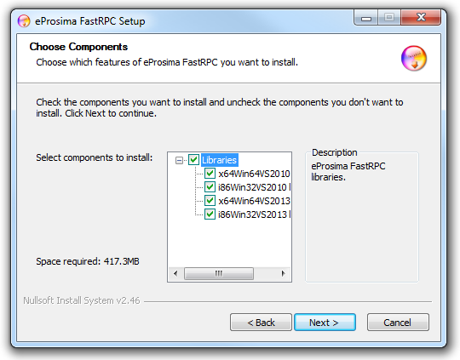
Once the main components have been selected click Next. Another page named Environment variable setting will be shown.
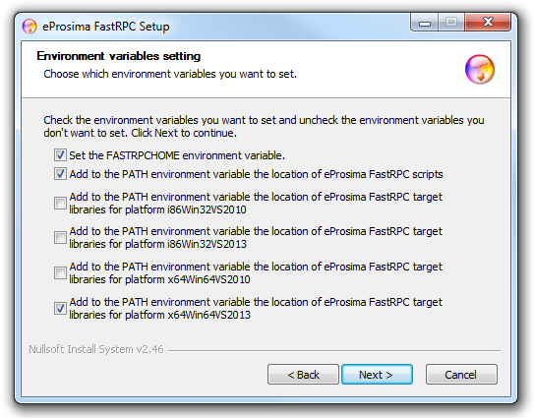
It is recommended to set the environment variable FASTRPCHOME and to make it point to the eProsima Fast RPC installation folder. Make sure this option is selected in the Environment variable setting step.
It is also convenient to append the fastrpcgen executable location directory to the PATH environment variable of the system. Make sure this option is selected in the Environment variable setting step.
The serialization library should also be accessible for your system. The installer offers the possibility of appending the location of the libraries you selected to install to the PATH environment variable. Make sure this option is selected in the Environment variable setting step.

Fedora 32-bit and 64-bit
Download the installation packages for your system.
eProsima_FastRPC-0.0.0-Fedora20.tar.gz

Extract its content.
Install the eProsima Fast RPC repository with one of these commands, depending on your operating system architecture. These commands install eProsima Fast RPC libraries. The headers will be installed in /usr/include/fastrpc and the libraries in /usr/lib64 (or /usr/lib if the library is installed in a 32-bit OS). They also install the fastrpcgen.sh script in /usr/bin, the examples in /usr/share/fastrpc and the documentation in /usr/share/doc/fastrpc.
yum localinstall i686/fastcdr-0.2.4-1.fc20.i686.rpm
yum localinstall i686/fastrpc-0.0.0-1.fc20.i686.rpm

yum localinstall x86_64/fastcdr-0.2.4-1.fc20.x86_64.rpm
yum localinstall x86_64/fastrpc-0.0.0-1.fc20.x86_64.rpm

Other Linux distribution 32-bit and 64-bit
Download the installation packages for your system.
fastcdr_0.2.4.tar.gz
eProsima_FastRPC-0.0.0-Linux.tar.gz

Extract its content. First, install the eProsima FastCdr library needed by eProsima Fast RPC. For 32-bit machines:
For 64-bit machines:
$ cd fastcdr; ./configure --libdir=/usr/lib; make; make install

$ cd fastcdr; ./configure --libdir=/usr/lib64; make; make install

Now, install the eProsima Fast RPC software. For 32-bit machines:
$ cd fastrpc; ./configure --libdir=/usr/lib; make; make install

For 64-bit machines:
$ cd fastrpc; ./configure --libdir=/usr/lib64; make; make install

